Specific gravity
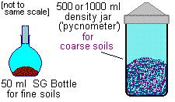
Specific gravity (G_{s}) is a property of the mineral or rock material forming soil grains.
It is defined as
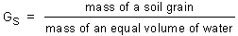
Method of measurement
For fine soils a 50 ml density bottle may be used; for coarse soils a 500 ml or 1000 ml jar. The jar is weighed empty (M₁). A quantity of dry soil is placed in the jar and the jar weighed (M₂). The jar is filled with water, air removed by stirring, and weighed again (M₃). The jar is emptied, cleaned and refilled with water - and weighed again (M₄).
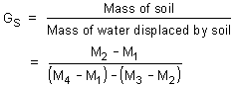
[The range of G_{s} for common soils is 2.64 to 2.72]

Volumes of solid, water and air: the soil model
- Degree of saturation
- Air-voids content
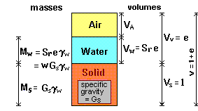
The soil model is given dimensional values for the solid, water and air components: Total volume,
V = V_{s} + V_{w} + V_{a}
Since the amounts of both water and air are variable, the volume of solids present is taken as the reference quantity. Thus, the following relational volumetric quantities may be defined:
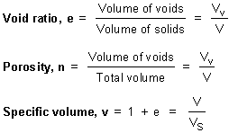
Note also that:
n = e / (1 + e)
e = n / (1 - n)
v = 1 / (1 - n)
Typical void ratios might be 0.3 (e.g. for a dense, well graded granular soil) or 1.5 (e.g. for a soft clay).

Degree of saturation
The volume of water in a soil can only vary between zero (i.e. a dry soil) and the volume of voids; this can be expressed as a ratio:
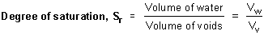
For a perfectly dry soil:
S_{r} = 0
For a saturated soil:
S_{r} = 1
Note: In clay soils as the amount water increases the volume and therefore the volume of voids will also increase, and so the degree of saturation may remain at S_{r} = 1 while the actual volume of water is increasing.

Air-voids content
The air-voids volume, V_{a} , is that part of the void space not occupied by water.
V_{a} = V_{v} - V_{w}
= e - e.S_{r}
= e.(1 - S_{r})
Air-voids content, A_{v}
A_{v} = (air-voids volume) / (total volume)
= Va / V
= e.(1 - S_{r}) / (1+e)
= n.(1 - S_{r})
For a perfectly dry soil:
A_{v} = n
For a saturated soil:
A_{v} = 0
Central Internet site BCA
http://central.tafe.wa.edu.au/CollegePortal/Dynamic/DynamicPge.asp?a=3352,0,Std&gid=63

http://www.dot.ca.gov/hq/esc/construction/Manuals/Foundation/ch.4_footing_foundations.pdf
4 CAPTER JULY 1997
CALTRANS • FOUNDATION MANUAL 4-1
Footing Foundations

